Notes

* Plots are from PRU datasets found here: <http://ansperformance.eu/data/performancearea/>
* Post-ops datasets (datasets adjusted by PRU with only data from 2016 to 2017) were not used, only the original.
* Date ranges from Jan 2011 to Oct 2018 overall but the range may vary within this for different KPIs, metrics and entities.
* ASMA delay/additional time is a proxy for average arrival runway queueing time, as ASMA time for each arrival is calculated while they are within 40NM of the airport and the ASMA delay is its difference compared to the statistically determined ASMA time of “un-impeded” flights.  
  <http://ansperformance.eu/references/methodology/unimpeded_asma_time.html>
* Similarly for the additional taxi-out time, this is the difference between the actual taxi-out time of a flight compared to a statistically determined “un-impeded” taxi-out time, which is a proxy for average departure runway queuing time.

<http://ansperformance.eu/references/methodology/unimpeded_taxi-out_time.html>

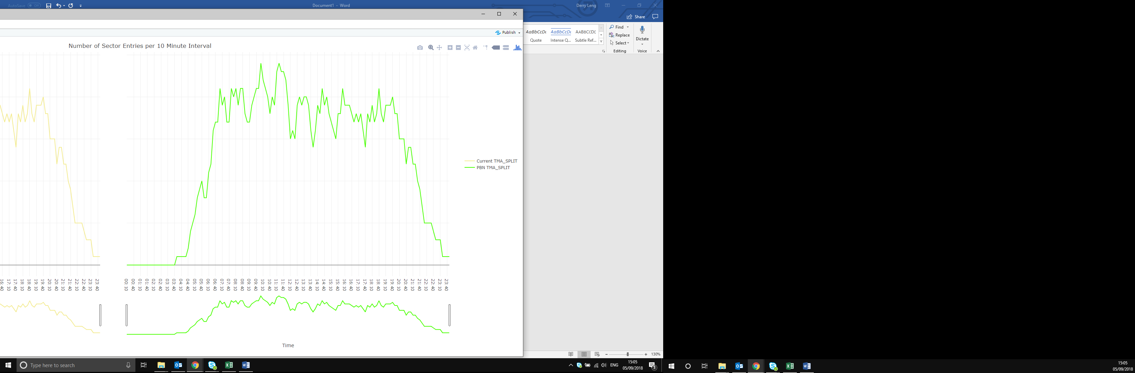Plot interaction

* When a plot is displayed, hovering over it will reveal options on the top right (see right), the options are:

Additional plot options on mouse hover

|  |  |
| --- | --- |
|  | **Download plot** (in current view) as .png file |
|  | Switch between **Zoom** (drag zooming) and **Pan** (drag moving) |
|  | **Zoom in** and **zoom out** of plot |
|  | **Autoscale** (fit all data in view) and **Reset Axes** (reset to default view) |
|  | **Toggle Spike Lines** shows lines from datapoint to intersect both x and y axes |
|  | **Show closest data point on hover** displays datapoint info when hovered |
|  | **Compare data on hover** displays info datapoints of same x value when hovered |

* 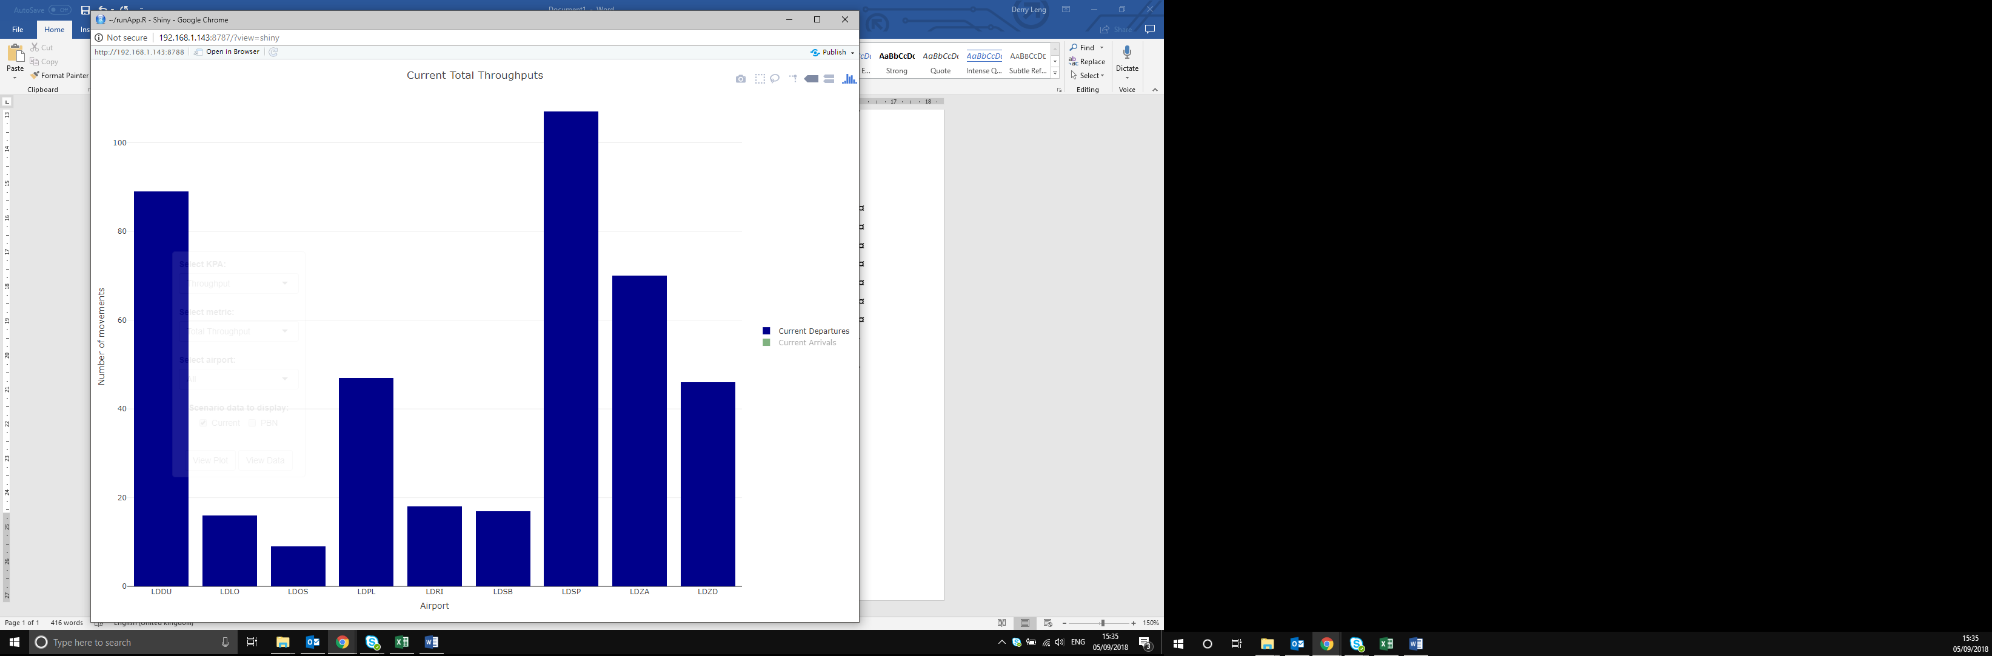If you are zoomed into the plot, double clicking anywhere on the plot will allow you to zoom out into the original magnification.
* Display of plot data can be toggled on and off by clicking the corresponding category in the legend. Categories can be isolated by double clicking.

Legend categories can be toggled

* 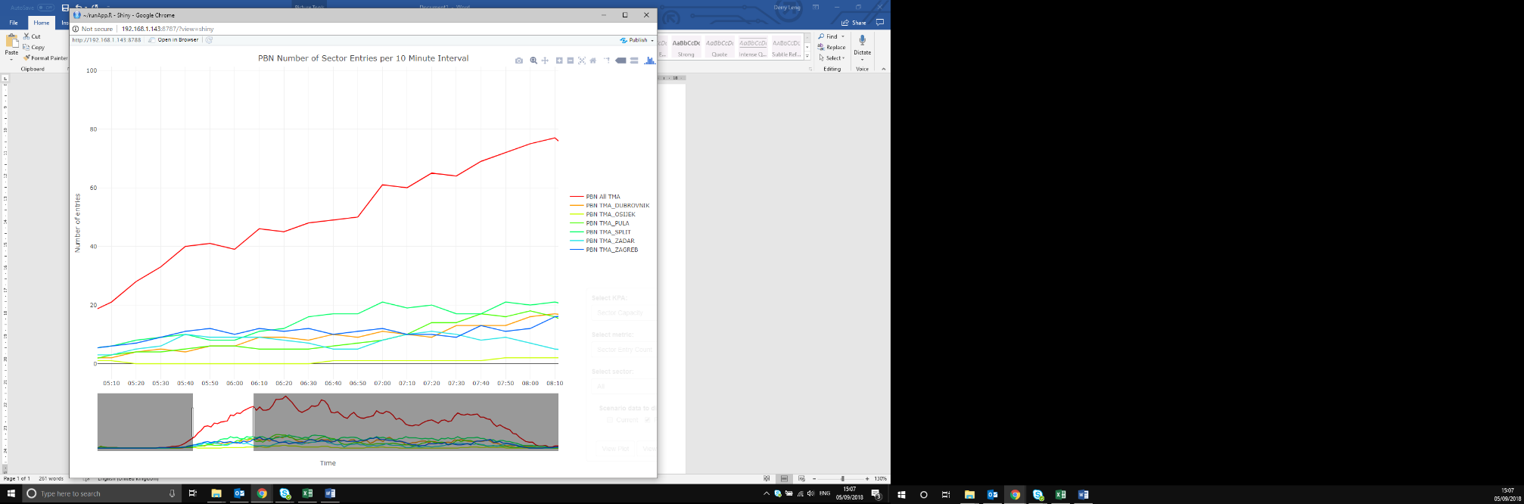Plots with time on x axis will have a range slider which allows for easier zooming to view data at specific time intervals.

Range slider